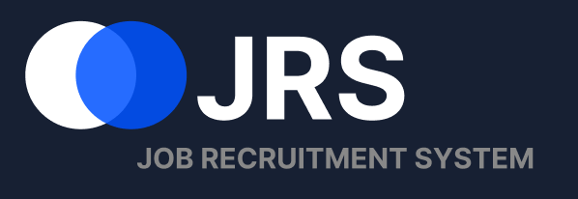
Individual Contribution, Self-Learning
and Project Management

Student | Shen Junye c3543464
Module | COMP3851A
Primary role | HR Recruitment Management Module
Word count | 1,000 words (main narrative)

1. Individual Contribution
My main responsibility was the HR Recruitment Management Module. I designed the HR Dashboard, Application Workflows, Resume Review, interview and rejection confirmation dialogs, and the Status Update Success page. I also created the HR relational database design and implemented Application Workflows with HTML, CSS and JavaScript. These outputs cover recruitment overview, application review, status management and candidate notification. The contribution table shows my estimated share of each result. I also checked shared terminology and required applicant data without claiming applicant-facing screens created by other members.
For the high-fidelity interface, I designed a dashboard summarising applications from job advertisements and interviews scheduled for today and the coming week. After feedback, I removed decorative statistics and unnecessary quick actions. I divided Applications into four queues: Offer, Pending Review, Rejected and Interview Results. Each shows its workload and next HR action. This is clearer than one long table because recruiters can finish one case, return to the queue and continue.
Resume Review became the central decision page. It presents the resume on the left and vacancy requirements on the right. I removed the match probability because it could imply an unreliable automated hiring decision. Previous and Next Candidate controls support continuous review. Next Step provides Move to Interview and Reject Candidate. Both dialogs show the status change, collect private notes or a rejection reason, and confirm notification. The success page records the new status and email result.
For the technical result, I modelled Department, Job Posting, Applicant Profile, Resume File, Application, HR Staff, HR Evaluation, Interview, Application Status History and Notification. Primary and foreign keys connect the candidate, vacancy, resume and HR action. I kept status history separate so earlier decisions are not overwritten, and notifications separate so delivery failures can be traced. The ERD therefore directly supports the interfaces.
I implemented the four workflow cards, candidate search, position and attention filters, candidate dialog and CSV export in one responsive HTML page. JavaScript filters candidate records and rebuilds the priority table when a queue or filter changes. Using realistic records, I checked that names, application IDs, positions and statuses remained consistent across the workflow, review, decision and success pages.
My integration work focused on the boundary between modules. I agreed the applicant, resume and application fields required from the applicant side and standardised HR status labels. I also considered rejection reasons, missing interviewer feedback, expiring offers and failed notifications. This identified the data that must be stored and prepared the prototype for Part B.
.
Estimated contribution to project results
Project result | My estimated share | Evidence / responsibility
Aim C — HR vacancy and recruitment overview | 50% | HR dashboard, active jobs and interview overview
Aim D — application review and status management | 80% | Four work queues, resume review and HR decision flow
Aim E — stage-based candidate notification | 70% | Notification choices, confirmation and delivery status
Section 5.2 — high-fidelity UI/UX prototype | 85% of HR result | Six HR screens and shared HR interaction patterns
Section 5.3 — relational ERD and HTML implementation | 80% of HR result | HR ERD and working Application Workflows page
Sections 5.1 and 5.4 — requirements and evaluation | 40% | HR traceability, integration and limitations
The percentages estimate my share of each result; they are not intended to total 100%.
2. Self-Directed Learning
I learned Figma Auto Layout, reusable components, prototype links and spacing systems so the six screens would behave like one product. I revised UML use-case relationships and studied database normalisation, cardinality, primary keys, foreign keys and audit-history modelling. For the HTML evidence, I practised responsive CSS, DOM events, array filtering, accessible modal behaviour and browser-generated CSV files. I also investigated privacy and human-in-the-loop recruitment. That learning directly changed my design: I removed the unsupported percentage evaluation and instead displayed the job requirements, explicit HR decisions, private notes and a status history. In Part B I will extend this learning to REST APIs, SQL migrations, role-based access and secure resume storage.

3. Project Management, Meetings and Teamwork
The work breakdown structure and 240-hour plan divided my work into requirements, interface design, ERD, HTML implementation and evaluation. The Gantt chart helped me see dependencies: applicant and application fields had to be agreed before the ERD, and the workflow layout had to stabilise before I coded it. Figma provided the shared design source, GitHub was intended for versioned implementation work, and meeting notes recorded decisions. I divided the HR module into reviewable screens and shared revisions before internal checkpoints, leaving time for corrections. Team coordination was normally weekly, with supervisor review approximately every two weeks during the interim period. I attended the meetings arranged for the project and participated by presenting the HR workflow, explaining design changes and asking questions about database integration. I did not remain only as a listener. Feedback from these meetings led to the four status queues, the simpler dashboard and the replacement of the evaluation percentage with job requirements. I coordinated respectfully with members responsible for applicant data and kept ownership boundaries clear. I delivered the dashboard, workflow, review screen, dialogs, ERD and HTML evidence in stages instead of on the final day. This gave the team time to find inconsistent labels and request changes. I applied the agreed revisions, checked the screens at full-page size and kept the evidence limited to my own HR work. I was not the formal project manager, but I managed the HR workstream, reported dependencies and completed the agreed items by the internal deadlines. To improve quality, I kept dated versions of the screens and compared each revision against the use cases. This prevented changes from removing required actions. When feedback conflicted, I returned to the HR task flow and selected the option that best supported traceability and implementation.

4. Part B Learning and Implementation Plan
In Part B, I will convert the prototype into a database-backed module. I will connect the four queues to persistent records, validate status changes on the server and create notification records transactionally. Unit, integration and end-to-end tests will cover filtering, duplicate decisions, rejection, interview progress and failed email delivery. I will also carry out accessibility checks and HR-style user tasks, then use the findings to improve the interface and document the final evaluation.
5. Evidence of Individual Work
The following figures are limited to my HR Recruitment Management Module. No applicant-facing or other members’ screens are included.

Figure 1. My HR Dashboard with the recruitment summary and interview schedule
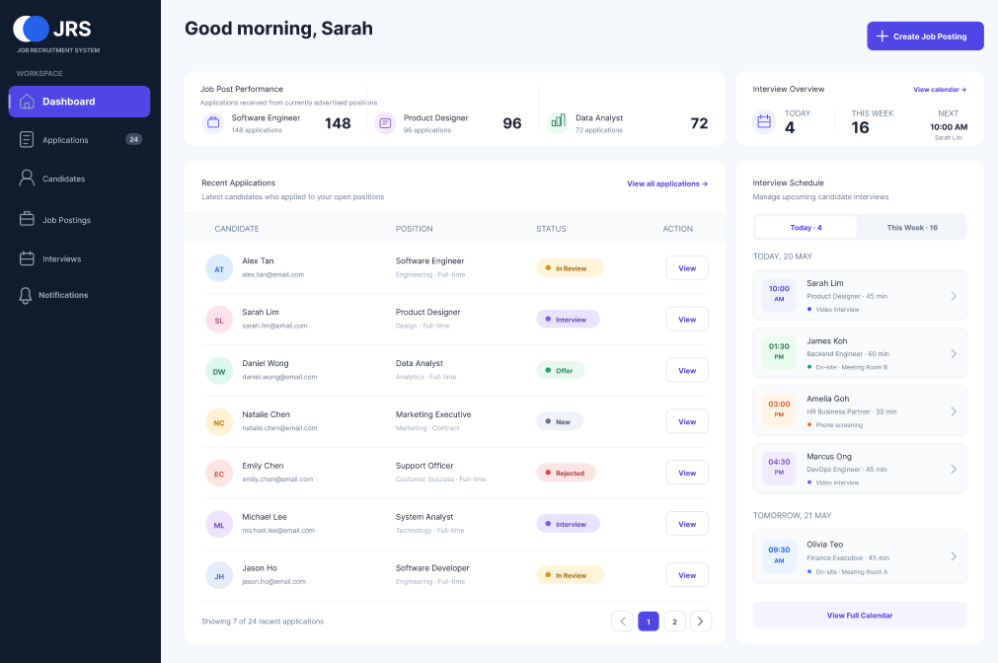
Figure 2. My four Application Workflows and Priority Work Queue
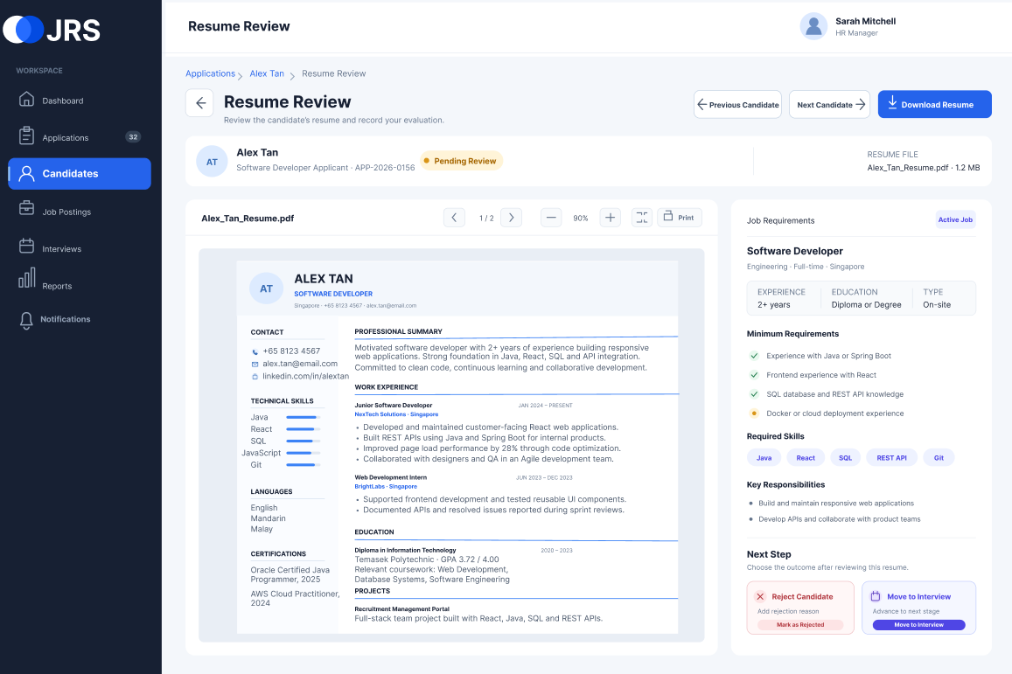
Figure 3. My Resume Review page comparing the resume with job requirements
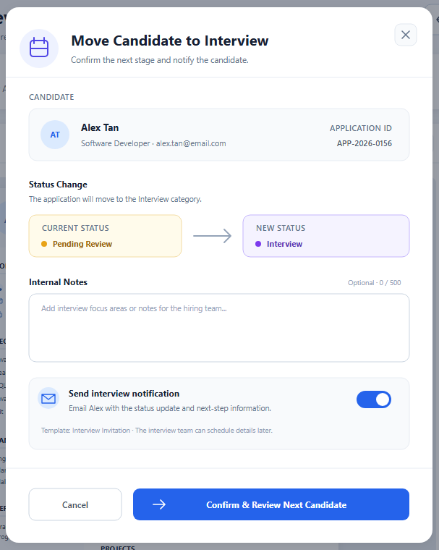 | 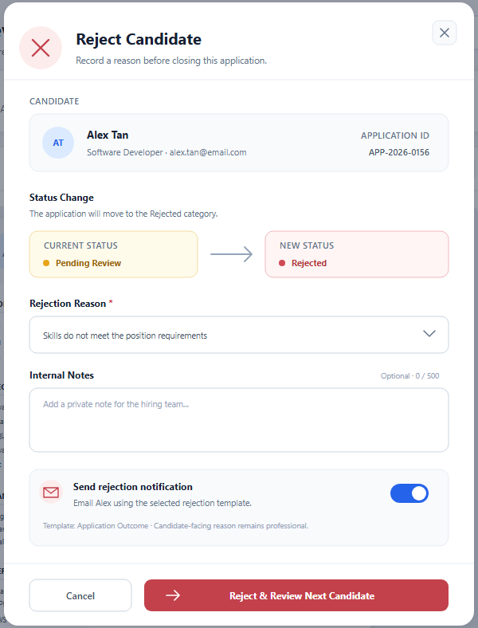
Figure 4. My Move to Interview and Reject Candidate decision dialogs

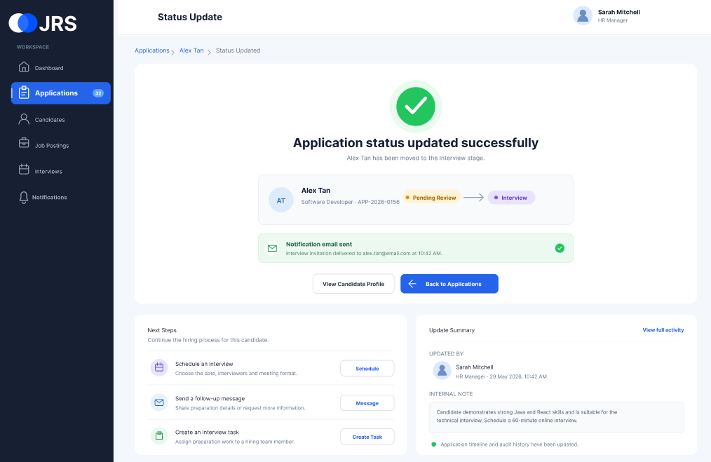
Figure 5. My Status Update Success page with notification confirmation
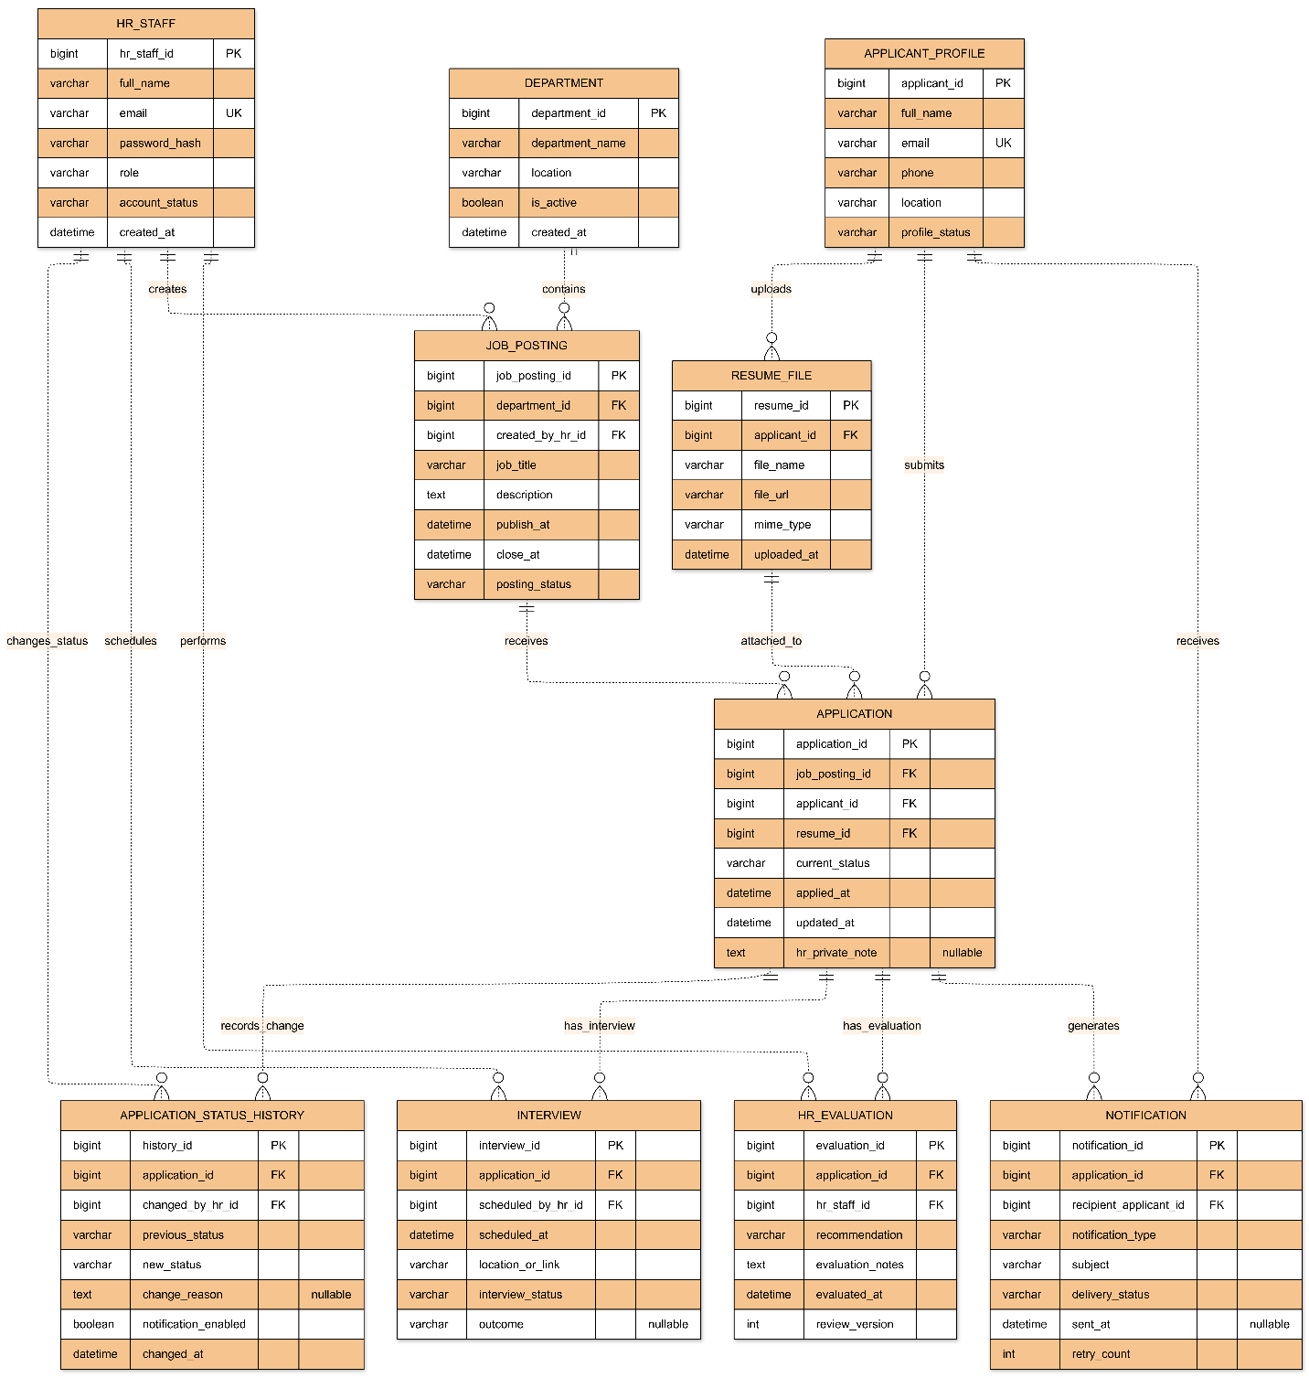
Figure 6. HR Recruitment Module ERD supporting my workflow

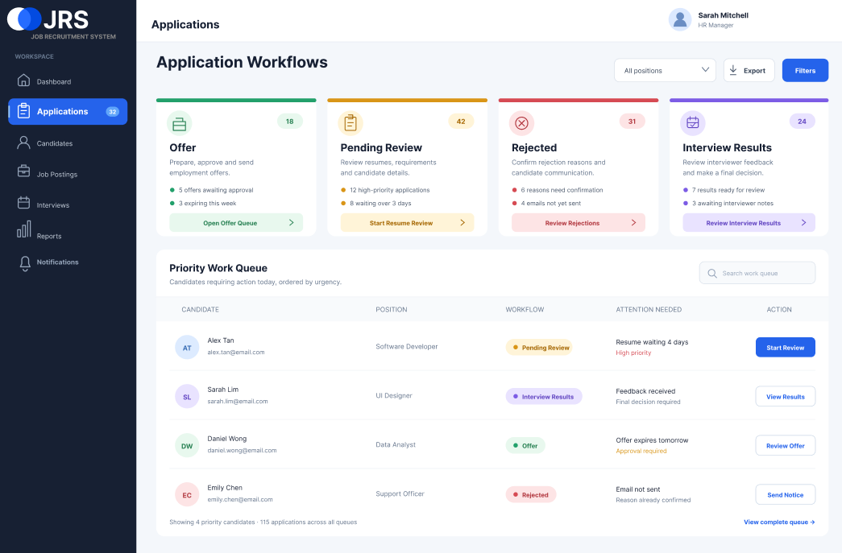
Figure 7. Working HTML implementation of my Application Workflows page

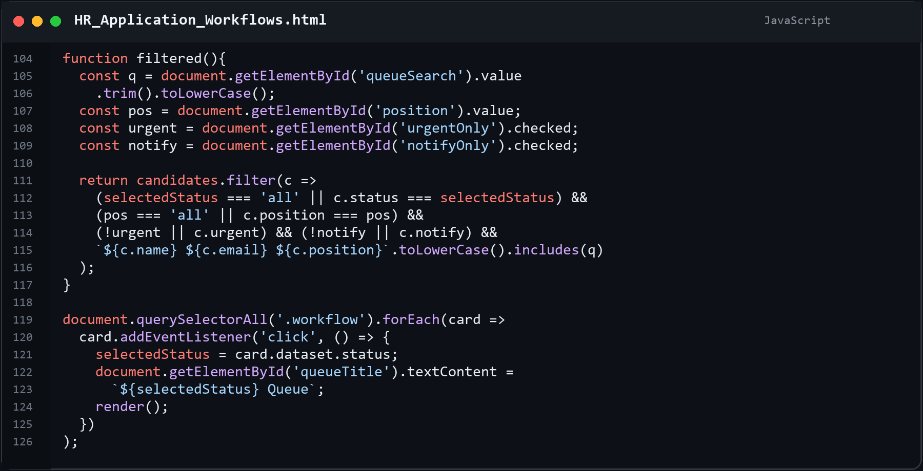
Figure 8. JavaScript used to filter the four HR work queues and refresh the candidate table

